CHAPTER FOUR

SYSTEM IMPLEMENTATION

4.1 Chapter Overview
This chapter documents how the designed phishing-detection system as described in Chapter Three was implemented and deployed as a production-ready web service and how it was realized in practice. The implemented features and the justification for the choice of programming language and frameworks are discussed. It also covers the rationale for technology choices (Flask + Render), engineering artifacts (code structure, save model), testing strategies adopted (unit and integration testing), target computer system requirements (hardware, software, environment), empirical results (model metrics and runtime measurements). After that, the results of the implementation - including functional outputs, performance metrics, and sample runs are also presented. Finally, those results are discussed, reflecting on successes, limitations, and lessons learned.

4.2 Features and Choice of Implementation Language

4.2.1 Features Implemented
The final implementation exposes the following production features (each item below describes design, why it was included, and important implementation notes):
- User authentication and session management (optional)
- •Purpose: control admin functionality (model upload, retrain, logs) and attribute requests to users for audit. The features should include registration and login functionality for users and administrators, as well as, session handling (e.g. via Flask’s session and cookies) to maintain user state.
- •Implementation: Flask sessions + secure password hashing (e.g. werkzeug.security.generate_password_hash / check_password_hash / flask_bcrypt). Store user records in the project’s data store (SQLite for small deployments; switchable to PostgreSQL in production). The user authentication aspect is an optional feature as the project was designed to be a FOSS (Free & Open Source Software).
- URL submission endpoint (web UI + REST)
- •Purpose: allow end users to submit single URLs or batch lists for classification.
- •Implementation details:
- •Frontend: a simple web form in index.html (POST to /phishnet) where a user inputs a URL, input validation (ensuring proper URL format, preventing injection) where submission triggers backend processing and result.html to present results.
- •REST: /api/phishy/ for programmatic use; returns JSON with pid, url, advisor, result, confidence, legit_rate, and phish_rate, and optionally a short explanation or key contributing features.
- Robust input validation & sanitization
- •Reason: prevent malformed input, injection attacks, and unnecessary network retrieval attempts.
- •Techniques: strict URL validation (using standard URL parsers), length checks, rejecting obviously malicious payloads (non-HTTP schemes), and applying timeouts to any optional HTTP fetches. In addition to this, there is graceful handling of invalid URL inputs, unreachable host errors, timeouts, and exceptions and error logging for debugging.
- Feature extraction pipeline (URL-only primary)
- •Purpose: transform raw URL (and optionally page HTML) into the 30-32-dimensional feature vector used by the classifier. This project documents a systematic extraction of address-bar, domain, and HTML/JavaScript-based attributes (e.g. IP address in URL, length, @ symbol, double slashes, subdomains, HTTPS presence, age-of-domain, iframe redirection indicators, number of external links, etc.).
- •Implementation: a single FeatureExtration class (file feature.py) that returns a deterministic feature list getFeaturesList() for a given URL; this is the exact interface used by app.py in the project. The FeatureExtraction class parses the URL string and extracts lexical, structural, and host-based features (e.g. domain length, count of special characters, hypens, presence of IP address, number of subdomains, etc.). The feature.py module maps raw URL → feature vector. Optionally, some content-based features if HTML is fetched (e.g. number of forms, external links) could be analyzed.
- ML inference module (production wrapper)
- •The trained model (Gradient Boosting Classifier produced the best test accuracy in the evaluation: ≈97.4%) is saved (e.g. pickle/model.pkl) and loaded at app startup for fast inference. Driver code in app.py loads the model object and calls phishnet() on the feature vector. The process starts by loading the pre-trained model and uses it to predict whether the submitted URL is phishy or legitimate and outputs a probability score or confidence measure, then uses the feature vector being generated as input.
- Result logging, history & analytics
- •Every prediction (pid, url, advisor, result, confidence, legit_rate, and phish_rate, and optionally SHAP/feature importance) is recorded in a results store/database to enable auditing, retraining, and analytics dashboards. This project documents a Results Log data store and UI for viewing logs. It also displays the prediction result to the user, along with interpreted information (e.g. which features most contributed - if explainability is integrated).
- Administrative model management
- •An optional admin interface would allow uploading a new model file, tagging versions, and rolling back to prior versions. The implementation persists models to a Model Store (file storage or cloud object storage) and references the active model in an environment variable or database record and model packaging for deployment.
- Optional explainability integration (recommended)
- •To increase trust and interpretability, compute local explanations (SHAP values) for each prediction and show the top 3 features that influenced the decision. This project contains feature-importance plots; adding SHAT at inference time is straightforward and recommended.
These features map closely to the functional requirements defined in earlier chapters.

4.2.2 Choice of Language and Frameworks
Choice of Implementation Language and Frameworks - Justification (Flask + Python)
- •Python was chosen as the primary language because of its mature and wide ecosystem for ML (scikit-learn, XGBoost/LightGBM, pandas, numpy) that simplify model loading, prediction, and data manipulation. Also, the ease of serializing models (joblib/pickle), and the availability of explainability packages (SHAP, LIME). This project uses Python and scikit-learn / GradientBoost in its pipeline and saved the trained model.
- •Flask was selected for the web layer because it is lightweight, requires minimal setup, easy routing, request parsing, templating (Jinja2), integrates smoothly with Python ML code, and is ideal for building small, secure web services and APIs. This project’s implementation uses Flask as present in app.py.
- •Render (Platform-as-a-Service - PaaS) was chosen for deployment because it offers simple Git-connected continuous deployment for web services, supports Python + Gunicorn workflows, and enables fast prototyping without managing infrastructure. Additionally, GitHub as a VCS (Version Control System), was selected for its source code version control capabilities and collaboration. Render’s docs and community guides describe a straightforward flow: connect your GitHub repo, select “New Web Service,” set build command (e.g., pip install -r requirements.txt), and set start command (e.g., gunicorn app:app).
Although this project could optionally include a Dockerfile and a Docker container screenshot (useful for local reproducibility and optional containerized deployment), the production deployment in this project used Render’s Web Service configuration (GitHub → Render → automatic deploy). The Dockerfile could also be retained in the repo if included, for teams that prefer containerized CI/CD or for deploying to Docker-friendly providers. Because phishing detection often requires fast response times and modular extensibility , the Python + Flask stack strikes a good balance between productivity and performance. Also, using established ML libraries reduces risk of building low-level model management from scratch.

4.3 Model Performance Analysis
During the course of the project development, a great deal of training implementations were carried out, in order to derive an astute and accurate prediction for the legitimacy of phishing websites. A compendium of the supervised algorithms used will be discusses further thus:
- •To begin, a vast number of libraries was imported, including but not limited to matplotlib, pandas, numpy, random forest classifier, decision tree classifier, among many others.
- •Examining and pre-processing the dataset, and plotting the data distribution.
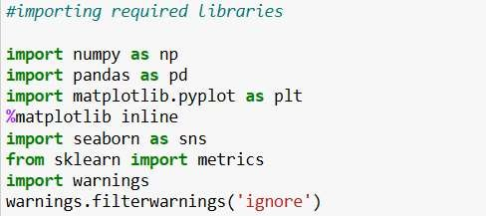

Figure 4.3.1 Importing Libraries
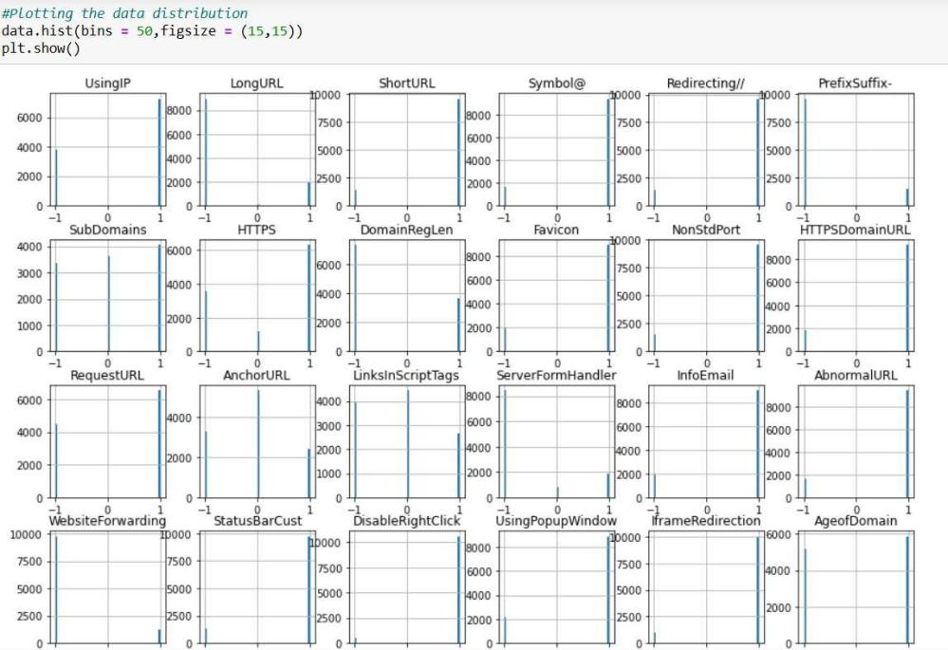
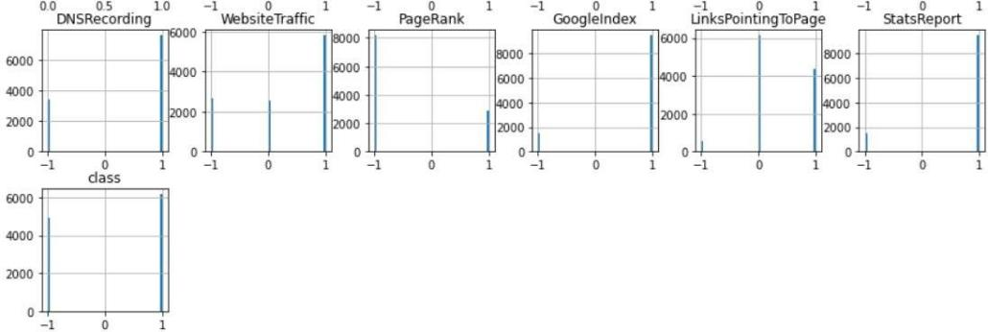

Figure 4.3.2 Data Distribution
- •After that, the dataset is split into both train and test datasets.
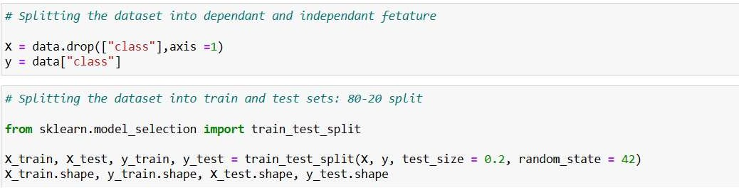

Figure 4.3.3 Splitting Dataset

